Oracle Database Administration Services
KE_Listener log housekeeping issue on windows

Submitted to



By



CIS, Wipro Limited

Document Details

Project Name | Innogy SE
Account | CIS
IT Component/Application Title | Listener Log housekeeping issue on windows
Current Version | 1.2
List of Contributors | Abhishek Kansal , Jiten Pansara
Customer Contact Information

Version History
(All revisions made to this document must be listed in chronological order. All revisions must be approved. Review and Approval can be done by an internal source or by the customer)
Version | Date of Revision | Description | Author | Reviewed By | Approved By
1.0 | 27/01/2018 | Initial Drafted | Jiten Pansara | Balaji Ankalle | Santosh Badiger
1.1 | 09/02/2018 | Document completed | Abhishek Kansal | Jiten Pansara | Santosh Badiger
1.2 | 20-12-2018 | Updated the content | Abhishek Kansal | Jiten Pansara | Santosh Badiger

Short Description:
While doing listener log housekeeping, we faced issues and not able to perform house keeping.
Root cause:
Listener log is in use hence other can’t modify the document.
Workaround:
- When you try to make changes to the listener log, you will get below errors.
** This mail has been sent from an external source **
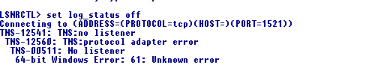

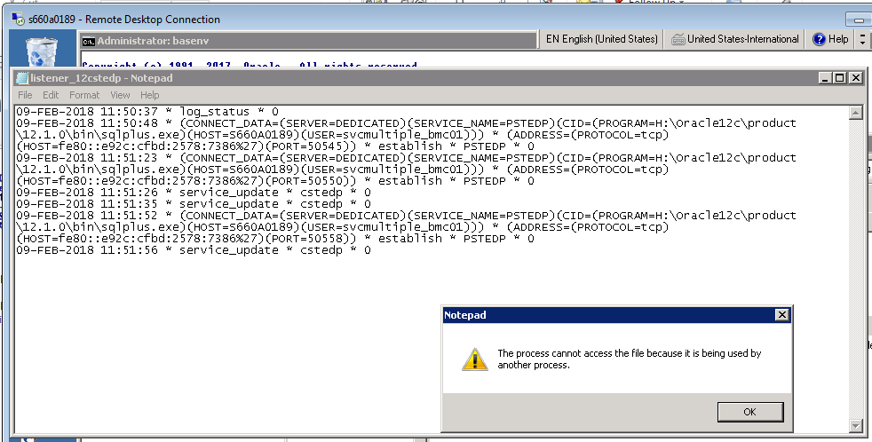

- To resolve it, you can perform below steps.

- Go to Oracle_HOME\network\log

- Use lsnrctl to change the log_status

- Lsnrctl

- Set current_listener <Listener_name>

- Set log_status off

- Perform the house keeping

- Set log_status on

